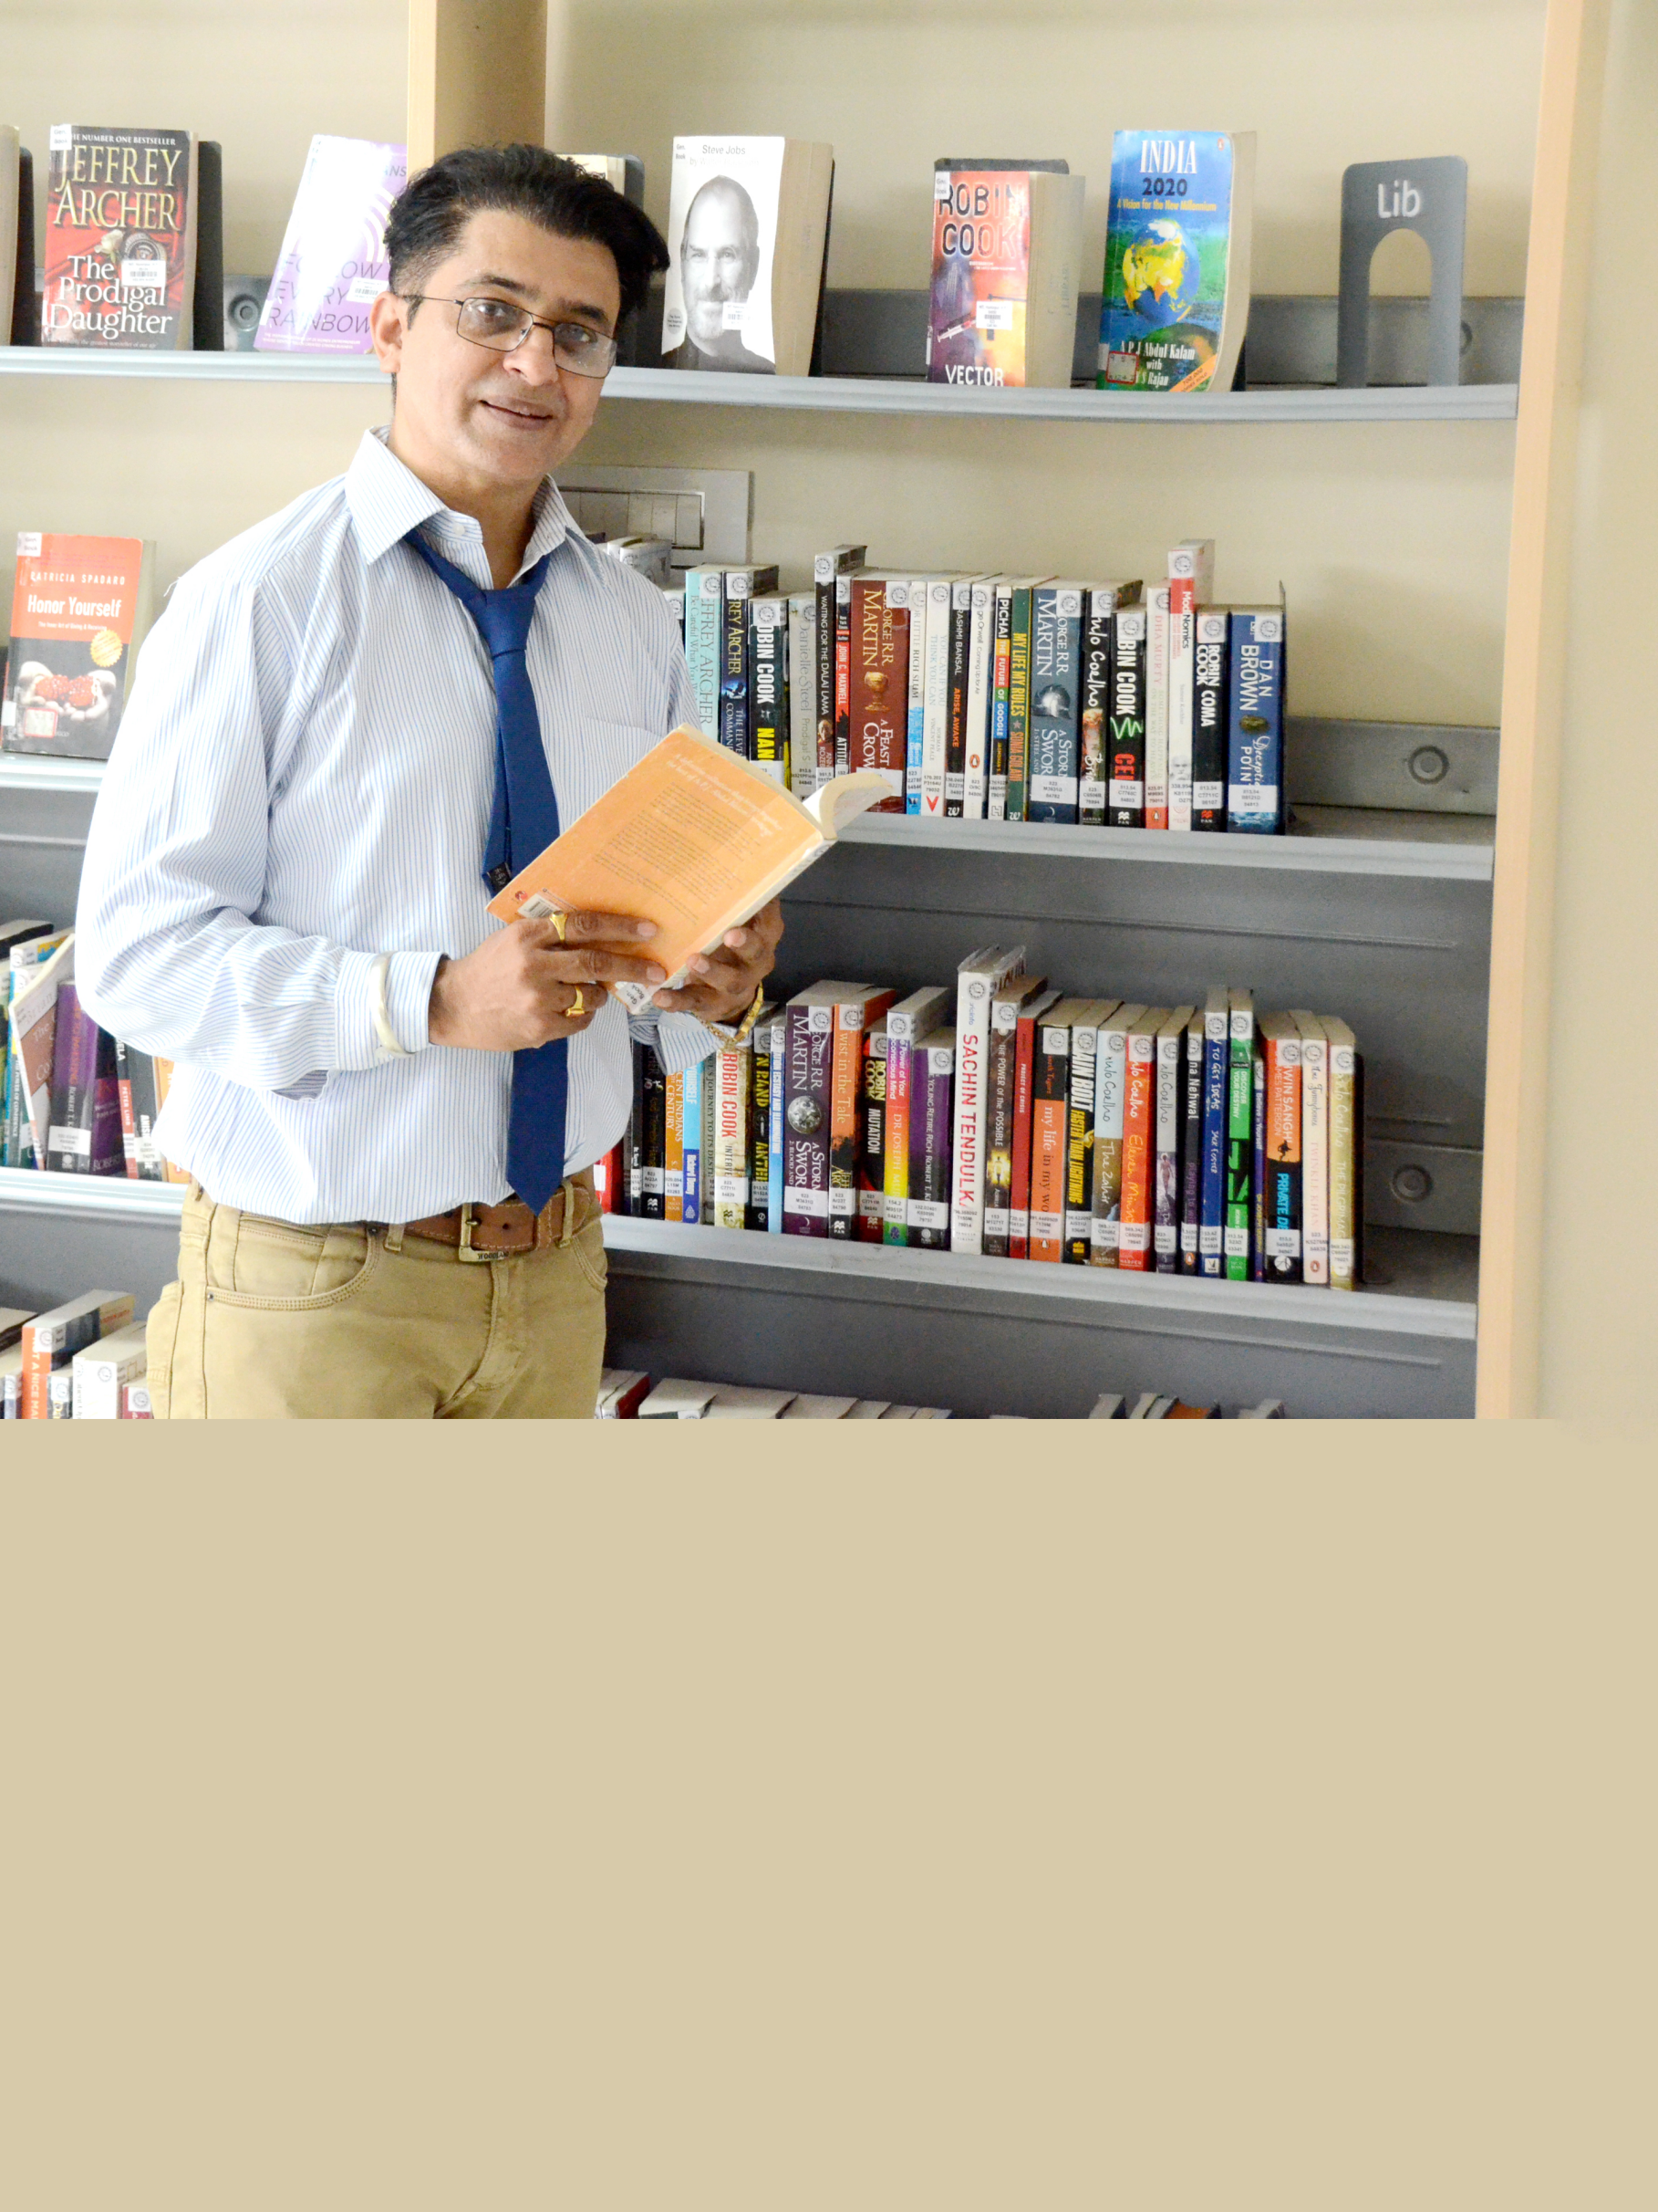I take immense pleasure in welcoming you to the picturesque campus of NIT Hamirpur. Being a premier technical institute of the country, NIT Hamirpur has maintained a rich tradition of pursuing excellence. The achievements of our alumni, some of whom have been distinguished names in their respective fields, speak volumes to our commitment towards meticulous academic and non-academic atmosphere.

I would take this opportunity to invite you for the recruitment of the batch of 2016. NIT Hamirpur offers a large talent pool to recruit from, with a wide range of specialization at different levels. I sincerely look forward to a warm and endearing relation between your reputed organization and NIT Hamirpur in the near future.

Best Regards,

Dr. Somesh Kumar Sharma